P PIZZA MANIA

A PROJECT SUBMITTED TO

DHARMSINH DESAI UNIVERSITY

NADIAD



“ MASTER IN COMPUTER APPLICATION”

SEM-1

(YEAR 2022-2024)

SUBJECT:- WEB DESIGNING

ROLL NO:-MA036

SUBMITTED BY:- AMEE D. PANCHAL

OBJECTIVE

The objectives for the pizza Mania **to establish the market presence needed to support marketing and sales goals and to attract customers**.

FUNCTIONALITY

This project provides for customer can see the update about our pizza mania and order the pizza. list of all pizza available in menu page .pizza mania provides very well services like free delivery , online payment and fresh food .user can registration after using services they gave feedback customer can Contact using contact page ,our shop location are mentioned under the Contact page. We are Serving Hand-Tossed Hot & Fresh Pan Pizza in affordable price, And Good Vibes.

TECHNOLOGY

1. Operating System : - Windows
2. For Designing Use :- Html ,CSS
3. Text Editor :- visual studio code
4. Browser :- Google Chrome

PROJECT CODING

1. Home page code:

< !DOCTYPE html>

<html lang="en">

<head>

<meta charset="UTF-8">

<meta http-equiv="X-UA-Compatible" content="IE=edge">

<meta name="viewport" content="width=device-width, initial-scale=1.0">

<link rel="stylesheet" href="style.css">

<link rel="stylesheet" href="https://cdnjs.cloudflare.com/ajax/libs/font-awesome/5.15.4/css/all.min.css">

<title>Pizza Website-2022</title>

</head>

<body>

<header class="head">

<h1>Pizza &nbsp; <i class="fas fa-pizza-slice"></i>&nbsp;Mania</h1>

<nav class="navbar">

<a href="#home">Home</a>

<a href="#menu">Menu</a>

<a href="#service">Services</a>

<a href="#contact">Contact</a>

<a href="#about">about</a>

</nav>

<div class="side-bar">

<a href="./loginpage.html.html"><b>Registrtion</b></a>

</div>

</header>

<div class="home-content">

<section style="height: 100vh;width: 100vw;background:url('./HI.jpg') no-repeat; background-size: cover;" class="home" id="home">

<div style="height: 100%;width: 100%;display: flex; justify-content: center; align-items: center; flex-direction: column;">

<h3 style="color: white; text-shadow: 2px 2px gray; background: rgba (225, 32, 32, 0.8);padding: 15px;border-radius: 5px;">

Welcome To Pizza Mania

</h3>

<p style="text-align: center;font-weight: bold;font-size: large;text-shadow: 1px 1px gray; color:black">Simply The Best. <br> Since 1973 Pizzamania has been serving THE VERY BEST PIZZA. <br> We built our reputation by using the finest ingredients available.</p>

<button class="btn">Menu</button>

</div>

</div>

</section>

2.Menu page code:

<section class="menu" id="menu">

<h4>Our Menu</h4>

<div class="menu-content">

<div class="in-box">

<i class="far fa-heart"></i>

<img src="friedpaneerpizza.jpg" alt="img" class="veg-icon">

<img src="7chhesipizza.jpg" alt="">

<div class="in-content">

<div class="star">

<i class="fas fa-star"></i>

<i class="fas fa-star"></i>

<i class="fas fa-star"></i>

<i class="fas fa-star"></i>

<i class="fas fa-star"></i>

<h2>Margherita Pizza</h2>

<div class="price">Rs 99.00</div>

<button class="btn">Add to Cart <i class="fas fa-plus-circle"></i></button>

</div>

</div>

</div>

<div class="in-box">

<i class="far fa-heart"></i>

<img src="cornpizza.jpg" alt="img" class="veg-icon">

<img src="cornpizza.jpg" alt="">

<div class="in-content">

<div class="star">

<i class="fas fa-star"></i>

<i class="fas fa-star"></i>

<i class="fas fa-star"></i>

<i class="fas fa-star"></i>

<i class="fas fa-star"></i>

<h2>Italian Tomato Pizza</h2>

<div class="price">Rs250.00</div>

<button class="btn">Add to Cart <i class="fas fa-plus-circle"></i></button>

</div>

</div>

</div>

<div class="in-box">

<i class="far fa-heart"></i>

<img src="squarepizza.jpg" alt="img" class="veg-icon">

<img src="squarepizza.jpg" alt="">

<div class="in-content">

<div class="star">

<i class="fas fa-star"></i>

<i class="fas fa-star"></i>

<i class="fas fa-star"></i>

<i class="fas fa-star"></i>

<i class="fas fa-star"></i>

<h2>Pepperoni Pizza</h2>

<div class="price">Rs 130.00</div>

<button class="btn">Add to Cart <i class="fas fa-plus-circle"></i></button>

</div>

</div>

</div>

<div class="in-box">

<i class="far fa-heart"></i>

<img src="friedpaneerpizza.jpg" alt="img" class="veg-icon">

<img src="friedpaneerpizza.jpg" alt="">

<div class="in-content">

<div class="star">

<i class="fas fa-star"></i>

<i class="fas fa-star"></i>

<i class="fas fa-star"></i>

<i class="fas fa-star"></i>

<i class="fas fa-star"></i>

<h2>Hamburger Pizza</h2>

<div class="price">Rs 200.00</div>

<button class="btn">Add to Cart <i class="fas fa-plus-circle"></i></button>

</div>

</div>

</div>

<div class="in-box">

<i class="far fa-heart"></i>

<img src="pizzaa.jpg" alt="img" class="veg-icon">

<img src="pizzaa.jpg" alt="">

<div class="in-content">

<div class="star">

<i class="fas fa-star"></i>

<i class="fas fa-star"></i>

<i class="fas fa-star"></i>

<i class="fas fa-star"></i>

<i class="fas fa-star"></i>

<h2>double chees Pizza</h2>

<div class="price">Rs 140.00</div>

<button class="btn">Add to Cart <i class="fas fa-plus-circle"></i></button>

</div>

</div>

</div>

<div class="in-box">

<i class="far fa-heart"></i>

<img src="heartpizza.png" alt="img" class="veg-icon">

<img src="heartpizza.png" alt="">

<div class="in-content">

<div class="star">

<i class="fas fa-star"></i>

<i class="fas fa-star"></i>

<i class="fas fa-star"></i>

<i class="fas fa-star"></i>

<i class="fas fa-star"></i>

<h2>love Pizza</h2>

<div class="price">Rs 120.00</div>

<button class="btn">Add to Cart <i class="fas fa-plus-circle"></i></button>

</div>

</div>

</div>

<div class="in-box">

<i class="far fa-heart"></i>

<img src="momospizza.jpg" alt="img" class="veg-icon">

<img src="momospizza.jpg" alt="">

<div class="in-content">

<div class="star">

<i class="fas fa-star"></i>

<i class="fas fa-star"></i>

<i class="fas fa-star"></i>

<i class="fas fa-star"></i>

<i class="fas fa-star"></i>

<h2>momos Pizza</h2>

<div class="price">Rs 150.00</div>

<button class="btn">Add to Cart <i class="fas fa-plus-circle"></i></button>

</div>

</div>

</div>

<div class="in-box">

<i class="far fa-heart"></i>

<img src="vegpizza.jpeg" alt="img" class="veg-icon">

<img src="vegpizza.jpeg" alt="">

<div class="in-content">

<div class="star">

<i class="fas fa-star"></i>

<i class="fas fa-star"></i>

<i class="fas fa-star"></i>

<i class="fas fa-star"></i>

<i class="fas fa-star"></i>

<h2>cheesbrust Pizza</h2>

<div class="price">Rs 170.00</div>

<button class="btn">Add to Cart <i class="fas fa-plus-circle"></i></button>

</div>

</div>

</div>

<div class="in-box">

<i class="far fa-heart"></i>

<img src="sweetspicepizza.jpg" alt="img" class="veg-icon">

<img src="sweetspicepizza.jpg" alt="">

<div class="in-content">

<div class="star">

<i class="fas fa-star"></i>

<i class="fas fa-star"></i>

<i class="fas fa-star"></i>

<i class="fas fa-star"></i>

<i class="fas fa-star"></i>

<h2>sweetspice pizza</h2>

<div class="price">Rs.$20.00</div>

<button class="btn">Add to Cart <i class="fas fa-plus-circle"></i></button>

</div>

</div>

</div>

</div>

</section>

3: Services page code:

<section class="service" id="service">

<h4>Services</h4>

<div class="service-content">

<div class="inner-box">

<img src="freedel.jfif" alt="">

<h2>Free Delivery</h2>

<p>For typical orders the time Guarantee is 40 Minutes, but the guarantee availability and time varies depending on a number of factors. If we are not at your door or lobby within the specified time limit, your order is free (the Time Guarantee).</p>

<button class="btn">Read More</button>

</div>

<div class="inner-box">

<img src="onlinepay.jfif" alt="">

<h2>Online Payment</h2>

<p>For your safety, and a contactless delivery, we are following a strict cashless payment method. Payments need to be made via online payment gateways/channels, UPIs, Wallets, Internet Banking, Airtel Money, PayZapp, Credit Card, Debit Card</p>

<button class="btn">Read More</button>

</div>

<div class="inner-box">

<img src="freshfood.jfif" alt="">

<h2>Fresh Food</h2>

<p>Pizza is a favorite food for many around the world.

The addicting combination of delicious crust, sweet tomato sauce and salty mozzarella cheese is sure to please even the pickiest of eaters.

However, it’s commonly labeled unhealthy, as it can be high in calories, sodium and carbs.</p>

<button class="btn">Read More</button>

</div>

</div>

</section>

4: Contact page code

<footer class="contact" id="contact">

<div class="contact-sec">

<div class="contact-inner">

<div class="contact-inner-col">

<img src="contect.jpg" alt="img" class="image">

</div>

<div class="contact-inner-col">

<h1>Contact US&nbsp;<i class="fas fa-paper-plane"></i></h1>

<p>Pizza-Mania maninagr road, shop no-10 iscon circle - Ahemdabad 382475 <br>

contect number is 848803275

</p>

<p>We Want To Hear From You, Write Us:</p>

<form action="#" id="" method="get">

<input type="text" name="name" id=" " placeholder="Please Enter Your Name" required>

<input type="email" name="name" id=" " placeholder="Please Enter Your emailid" required>

<input type="text" name="name" id=" " placeholder="Please Enter Your phonenumber" required>

<input type="text" name="name" id=" " placeholder="Please Enter Your adress" required>

<textarea name="" id="" cols="10" rows="8"></textarea>

<button class="btn">Submit</button>

</section>

</form>

</div>

</div>

Location code:

<h2>our shop location</h2>

<div class="map">

<iframe src="map.PNG" width="100%" height="250" style="border:0;" allowfullscreen="" loading="lazy"></iframe>

</div>

<section class="location" id="location">

5: about us page code:

<section class="about" id="about">

<h4>About</h4>

<div class="about-sec">

<div class="img">

<img src="freahpiza.jfif" alt="img">

</div>

<div class="about-content">

<h3>Pizza Mania</h3>

<p>The Pizza Mania is your neighborhood hangout serving hand-tossed Hot & Fresh Pan Pizza, local drafts, and good vibes. We offer both #Vegan and #glutenfree pizza! Let The Pizza Mania be your upcoming Venture!</p>

<div class="about-inner">

<h5><i class="fas fa-arrow-alt-circle-right"></i>Good Quality</h5>

<h5><i class="fas fa-arrow-alt-circle-right"></i>Fresh Vagetables</h5>

<h5><i class="fas fa-arrow-alt-circle-right"></i>Available 24X7</h5>

<h5><i class="fas fa-arrow-alt-circle-right"></i>Best Price</h5>

<h5><i class="fas fa-arrow-alt-circle-right"></i>affordable price</h5>

</div>

</div>

</div>

</section>

<div class="">

<center> <img src="the.jpg" alt="" height="250" width=""> </center>

</div>

</div>

</div>

</footer>

6:java script code:

<script>

let menu = document.querySelector('.head .navbar');

document.querySelector('#bars').onclick = () => {

menu.classList.toggle('active');

searchfrm.classList.remove('active');

}

window.onscroll = () => {

menu.classList.remove('active');

searchfrm.classList.remove('active');

}

</script>

</html>

CSS file code:

@import url('https://fonts.googleapis.com/css2?family=PT+Sans&display=swap');

:root {

--clr1: #14064b;

--clr2: #fff;

--clr3: #000;

--clr4: #25b6ef;

--clr5: limegreen;

}

* {

margin: 0;

padding: 0;

box-sizing: border-box;

font-family: 'PT Sans', sans-serif;

text-decoration: none;

text-transform: uppercase;

}

html {

font-size: 65%;

scroll-behavior: smooth;

scroll-padding-top: 8rem;

overflow-x: hidden;

}

html::-webkit-scrollbar {

width: 1rem;

}

html::-webkit-scrollbar-thumb {

background:gray;

border-radius: 15px;

}

.btn {

margin-top: 2rem;

padding: 1.3rem 4rem;

font-size: 1.5rem;

text-transform: capitalize;

letter-spacing: .1rem;

font-weight: 500;

color: #000;

background-color: #fff;

border: none;

border-radius: .5rem;

box-shadow: 0rem 2rem 2rem rgba(0, 0, 0, 0.1);

transition: all 0.3s ease 0s;

cursor: pointer;

outline: none;

}

.btn:hover {

background-color: var(--clr3);

box-shadow: 0px .2rem 2rem rgba(255, 85, 94, 0.4);

color: #fff;

transform: translateY(-1rem);

}

.btn:active {

transform: translateY(-.1rem);

}

section {

padding: 4rem 9%;

margin-top: 8rem;

}

section h3 {

font-size: 3rem;

color: var(--clr2);

text-transform: none;

text-align: center;

letter-spacing: .2rem;

}

section h4 {

margin: 0 0 1rem 25rem;

padding: .2rem;

width: 50%;

font-size: 3rem;

color: var(--clr2);

text-transform: none;

text-align: center;

align-items: center;

letter-spacing: .2rem;

clip-path: polygon(0% 15%, 25% 28%, 15% 0%, 85% 0%, 70% 28%, 100% 15%, 100% 85%, 67% 70%, 85% 100%, 15% 100%, 28% 66%, 0% 85%);

background: var(--clr4);

}

section h2 {

padding: 2rem 0;

font-size: 2rem;

font-weight: 700;

color: var(--clr3);

text-transform: capitalize;

letter-spacing: .1rem;

}

section p {

color: var(--clr2);

font-size: 1.5rem;

text-transform: capitalize;

line-height: 2.5rem;

word-wrap: normal;

}

.head {

position: fixed;

top: 0;

left: 0;

right: 0;

z-index: 1000;

display: flex;

background: var(--clr4);

color: var(--clr2);

padding: 3rem 9%;

align-items: center;

justify-content: space-between;

}

.head h1 {

font-size: 2.5rem;

}

.head .fa-pizza-slice {

animation: icon 5s ease infinite;

}

@keyframes icon {

25% {

transform: translateY(-1.5rem);

}

50% {

transform: translateY(1.5rem);

}

}

.head .navbar a {

color: var(--clr2);

font-size: 1.6rem;

font-weight: 600;

margin: 0 2rem;

}

.head .navbar a:hover {

transition: .4s ease;

color: var(--clr3);

}

.head .side-bar i {

padding: 1.5rem;

font-size: 2.1rem;

border: none;

background: var(--clr2);

color: var(--clr4);

}

.head .side-bar i:hover {

background: var(--clr3);

color: var(--clr4);

transition: .5s ease all;

}

#bars {

display: none;

}

/*------------------------Home Section--------------------*/

.home {

height: 100vh;

background: linear-gradient(rgba(13, 16, 16, 0.5), rgba(79, 32, 32, 0.5)), url(back1.png) no-repeat;

background-size: cover;

background-position: center;

}

.home-content {

display: grid;

grid-template-columns: 1.2fr 1.2fr;

}

.img{

width: 500PX;

clip-path: circle();

}

.inner-content {

max-width: 70rem;

margin-top: 20rem;

text-align: center;

}

.inner-content-img {

margin-top: 2rem;

}

.inner-content-img img {

width: 45rem;

height: auto;

animation: icon 5s ease infinite;

}

.inner-content i {

color: var(--clr4);

}

/*---------------about section---------*/

.about-sec {

display: grid;

grid-template-columns: 1.2fr 1.2fr;

}

.img img {

width: 45rem;

height: auto;

text-align: center;

animation: icon 4s ease infinite;

}

.about-content h3 {

background: url(back.png);

background-size: cover;

background-position: center;

color: var(--clr4);

}

.about-content p {

padding-bottom: 2rem;

color: var(--clr3);

font-size: 1.4rem;

font-weight: 600;

}

.about-inner h5 {

padding: 1rem 0;

font-size: 1.5rem;

text-transform: capitalize;

font-weight: 900;

}

.about-inner h5:hover {

transition: 1s ease;

transform: translateX(2rem);

}

.about-inner .fas {

color: var(--clr4);

padding-right: 1rem;

}

.about-content .btn {

border: .1rem solid var(--clr4);

}

/*---------------service section------*/

.service-content {

padding: 1rem 0;

display: grid;

grid-template-columns: 1.2fr 1.2fr 1.2fr;

grid-gap: 1rem;

}

.service h3 {

color: var(--clr4);

}

.inner-box {

padding: 3rem 2rem;

text-align: center;

border: .1rem solid var(--clr4);

background: #eee;

}

.inner-box:hover {

background: var(--clr4);

transition: .5s ease all;

}

.inner-box img {

width: 15rem;

height: 15rem;

}

.inner-box p {

font-size: 1.3rem;

color: var(--clr3);

}

/*--------------menu section--------*/

.menu-content {

display: grid;

grid-template-columns: 1.2fr 1.2fr 1.2fr;

grid-gap: .5rem;

flex-wrap: nowrap;

}

.in-box {

padding: 3rem 4rem;

text-align: center;

border: .1rem solid var(--clr4);

background: #eee;

}

.in-box:hover {

background: var(--clr4);

transition: .4s ease all;

}

.in-box img {

width: 20rem;

height: auto;

}

.in-box .far {

position: absolute;

font-size: 2.5rem;

margin-left: -7rem;

color: var(--clr3);

}

.in-box .veg-icon {

margin-left: 22rem;

position: absolute;

width: 3rem;

}

.star,

.price {

padding: 1rem 0;

font-size: 1.8rem;

font-weight: 600;

color: var(--clr3);

text-transform: capitalize;

}

.fa-star {

color: var(--clr5);

}

.in-box .far {

font-size: 2rem;

color: var(--clr3);

}

.in-box .fa-plus-circle {

color: var(--clr4);

}

/*-------------------contact---------------*/

.contact {

padding-top: 3rem;

}

.contact-sec {

width: 100%;

}

.contact-inner {

display: flex;

flex-wrap: wrap;

justify-content: center;

align-items: center;

}

.contact-inner-col {

margin: 2rem;

flex: 1 1 20rem;

text-align: center;

}

.contact-inner-col img {

width: 100%;

height: auto;

margin: 1.5rem;

padding: 1rem;

}

.contact-inner-col h1 {

padding: 1rem 0;

color: var(--clr3);

font-size: 3rem;

letter-spacing: .1rem;

text-transform: capitalize;

}

.contact-inner-col p {

padding: .5rem 0;

line-height: 1.5rem;

font-size: 1.5rem;

text-transform: capitalize;

}

.contact-inner-col input,

.contact-inner-col textarea {

width: 80%;

padding: 1rem;

margin-bottom: 1.2rem;

color: rgb(17, 13, 58);

border: none;

border-bottom: .3rem solid var(--clr4);

}

textarea {

resize: none;

}

.map {

border: .1rem solid var(--clr3);

}

.copyright {

display: flex;

margin-top: 5rem;

padding: 3rem;

text-align: center;

justify-content: space-between;

background: #aaa;

}

.copyright i {

font-size: 2rem;

color: var(--clr2);

}

.copyright p {

letter-spacing: .1rem;

font-size: 1.5rem;

color: var(--clr2);

}

.social i {

padding: 1rem;

background: var(--clr4);

color: var(--clr2);

font-size: 1.5rem;

}

.social i:hover {

transform: translateY(-2rem);

color: var(--clr2);

cursor: pointer;

transition: 1s ease;

}

Website pages:

Home page:

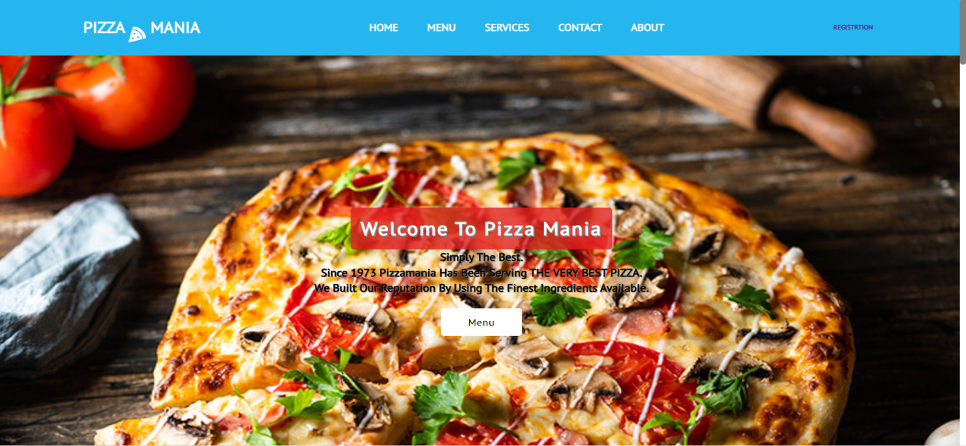

Menu page:

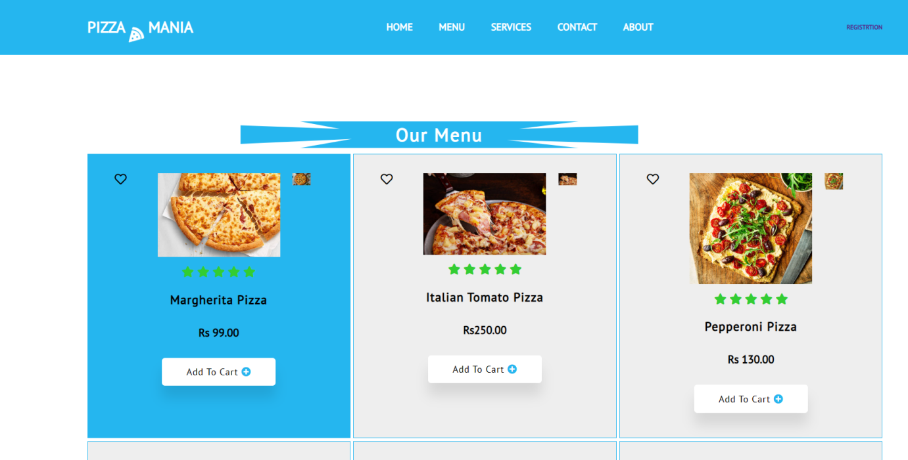

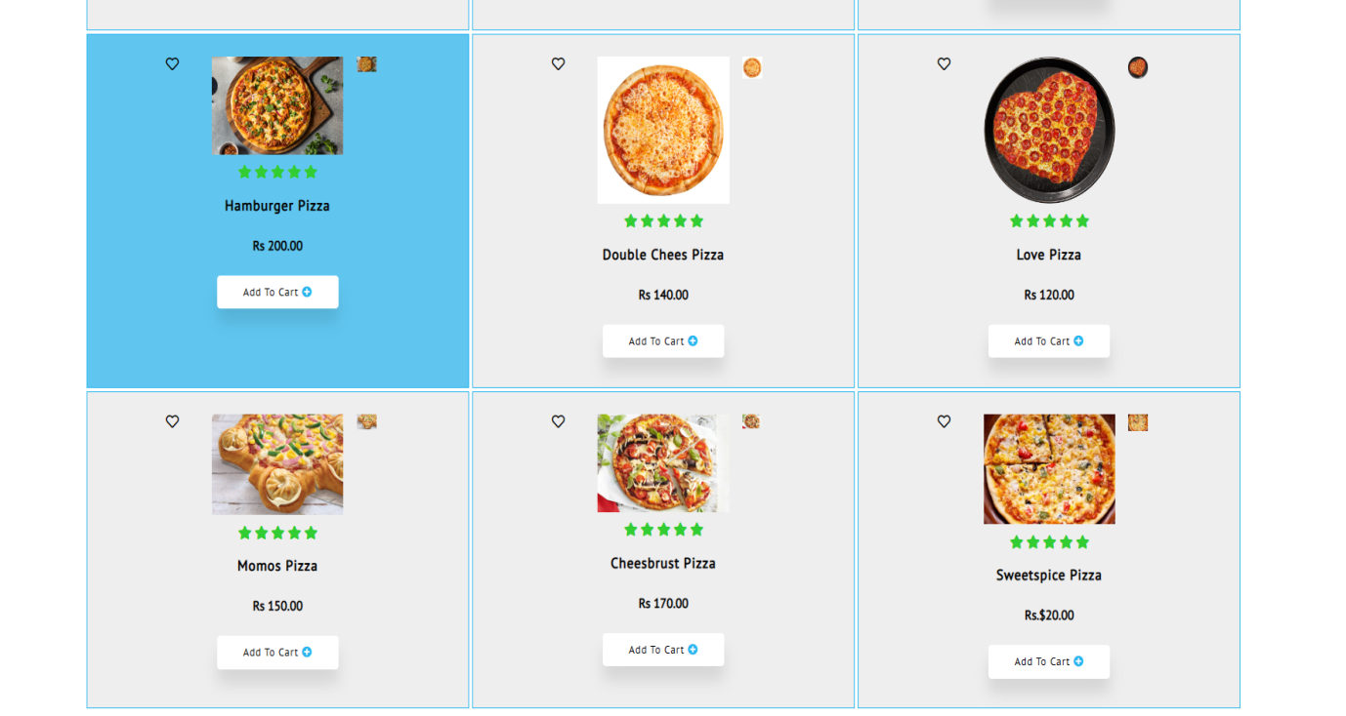

Services:

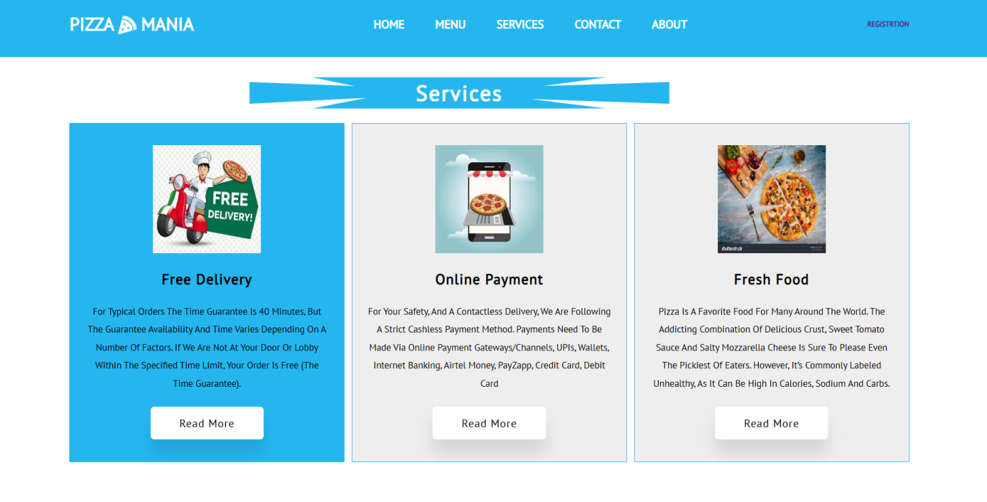

Contact us:

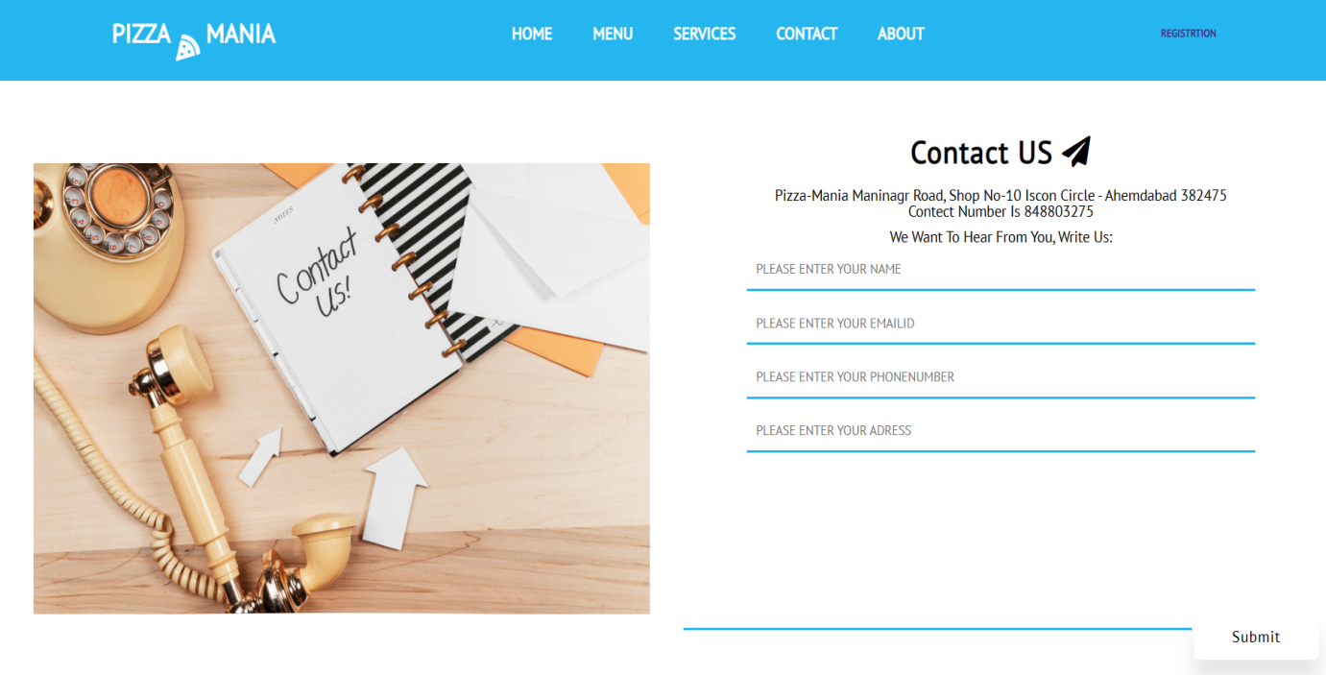

Location:

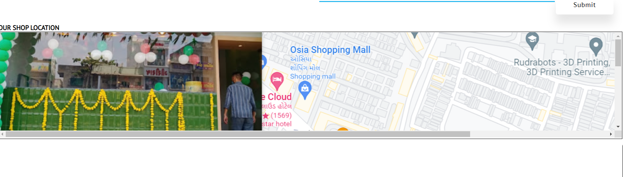

About us:

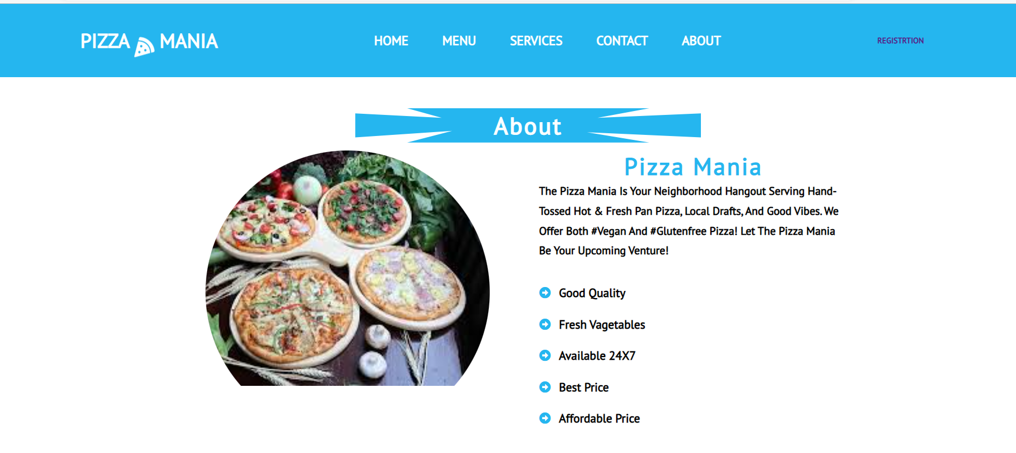

Registration form:

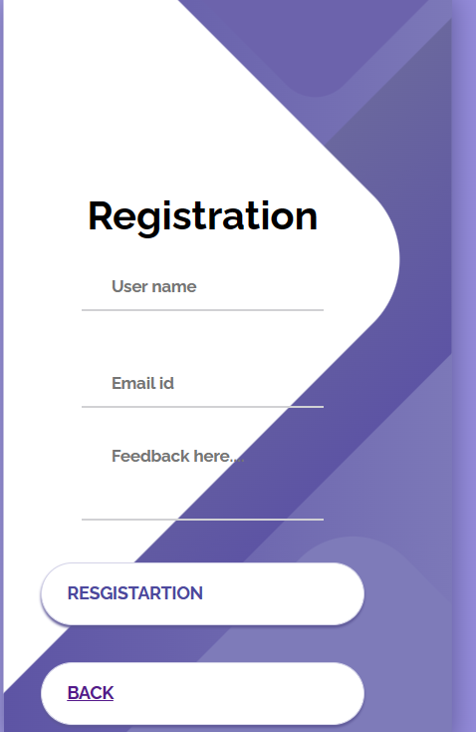

Thank you